Eight Discipline Report (8D Report)
To: Customer |  | 8D report No.: CPCQ2000601
From:：Chicony Power Technology |  | RMA claim No.: N/A
CC： N/A |  | Chicony P/N: A065RP25P-HW01-0A
 |  | Customer P/N:
Submit date: | 2020/06/24 updated | Product description: 65W adapter
Receive date: | 2020/06/01 | Defect D/C or Lot No.: 2020/04
Subject：ESD Test Fail*1pcs
D1.) 問題解決成員:Use Team Approach
主持者 (Team Leader)：Henry_Zhang
內部成員 (Internal Team Members):

CQS | Sunny_Dang
MFG | Ice_Liu
IPQC/QE | BL_Zhang
PE | XP_Zhao
IE | Hunter_Liao
SQE | Yanlan_Qin

外部成員 (External Team Member):
N/A
D2.)問題說明:Problem Description:
(Note: Use who, what, when, where, why, how, how many to specify the Customer’s problem.)
2020/05/29, Customer CQ反饋我司HP 65W adapter ESD test fail*1pcs.
Customer P/N: xxxx
CPT P/N: A065RP25P-HW01-0A
Defect S/N:WJEKF0AGCDL8EA
Defect D/C: 2020/04/09
D3.)內部或客戶的暫時解決辦法及實施日期:Implement and Verify Containment Action:
(Note: Internal / external containment action effectiveness and date.)
- CPT FAE 將adapter 帶回廠內進一步分析.
Owner: FAE Date: 2020.06.01
D4.)不良原因確認: Define and Verify Root Causes:
(Note: Identify and verify all suspect causes, which needs explain why the problem occurred.)
- 生產記錄：
根據退回產品S/N,查詢廠內SFCS記錄正常.
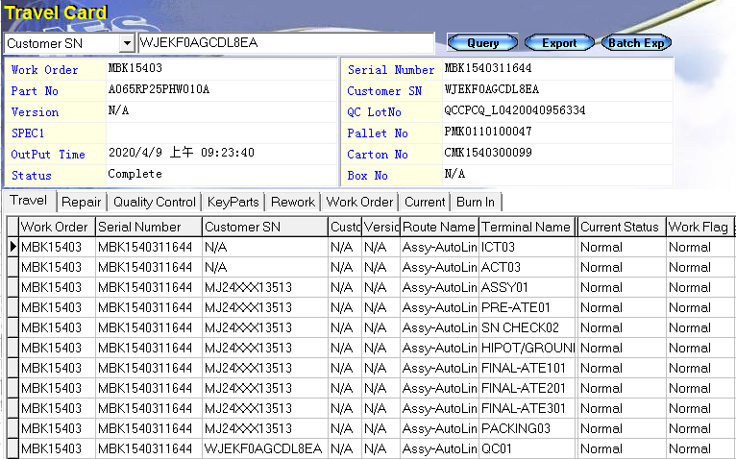
- 實物確認:
檢查adapter外觀無異常,通電測試確認產品無輸出(如下圖).
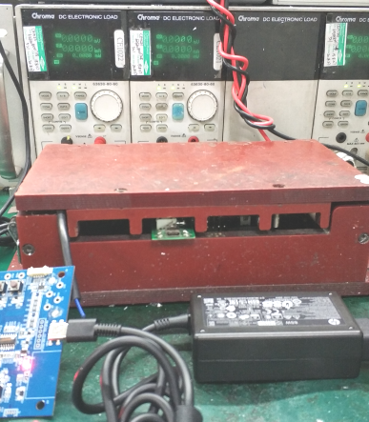
- 不良分析:
3.1.開殼檢查確認零件面及錫面無異常;逐次量测锡面各個零件(如下圖).
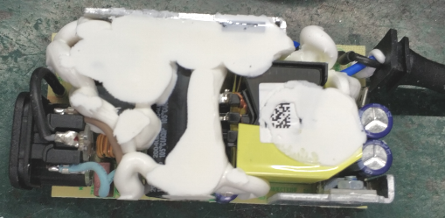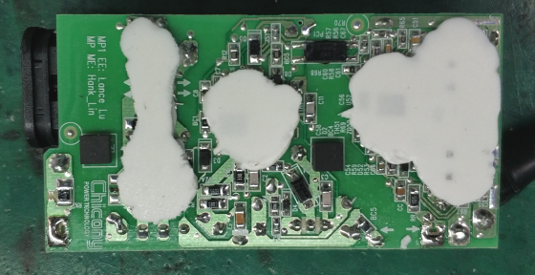
3.2.逐步排查不良adapter錫面各零件,懷疑U1 Fail;進行交叉驗證,將良品adapter的U1取下,更
換在不良adapter,通電測試確認該adapter輸出無異常(如下圖).
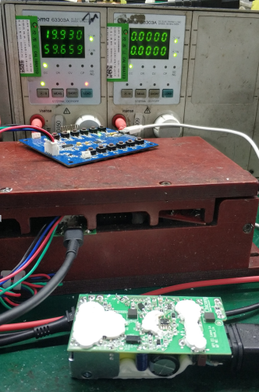
不良adapter+良品adapter的U1
3.3.將被懷疑不良的U1裝回不良adapter,通電測試確認該adapter無輸出(如下圖).初步確認不
良adapter的U1 Fail.
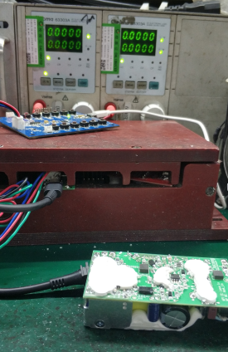
不良adapter+不良adapter的U1

- 電路分析:
U1零件不良,導致產品無輸出.
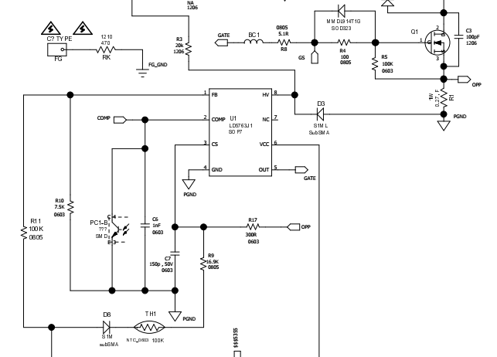
綜合分析:U1 Fail從而導致產品無輸出.
D5.)改善措施: improvement measure:
(Note: Be make sure the corrective actions is effective in process as well as able to fix the customer complaint problem)
- 將不良零件送予廠商分析為HV內部第一級線路遭外部異常能量EOS Damage.廠商分析報告如下:
料號:601022001522TSHF 廠商:LEADTREND
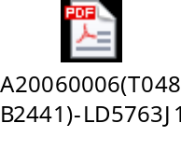
- 廠內生產情況調查:
a.調查不良品所在工單(MBK15403)首件ESD測試結果PASS.
b.該U1在xxxx機種截止6/3日使用了34,952pcs.查詢廠內維修記錄,無不良.
- 為了補強adapter的ESD放電能力,取良品adapter,進行不同放電pin距離的驗證測試.
3.1.將5pcs良品adapter,進行ESD Air Discharge測試.驗證結果如下:
條件 | Result
20KV | 1pc Fail
20.5KV | 1pc Fail
21KV | 3pc Fail
3.2.將1pcs良品adapter,在PCB板上RK的銅箔尖點處,縮短放電pin距離,進行ESD Air
Discharge測試.驗證到25KV產品Pass.
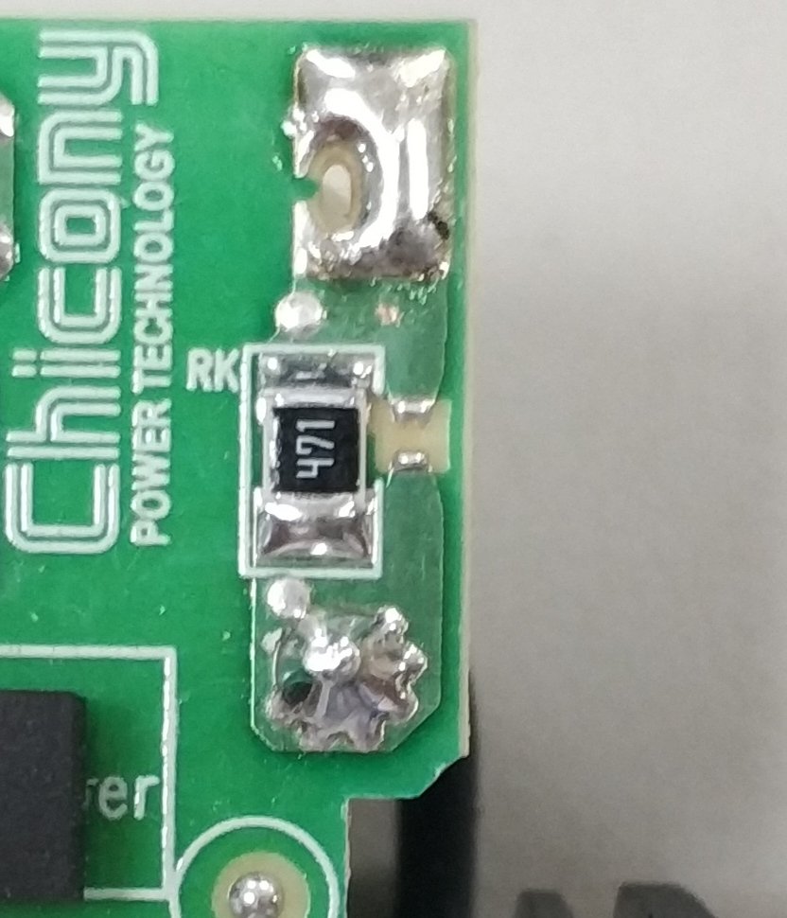 | 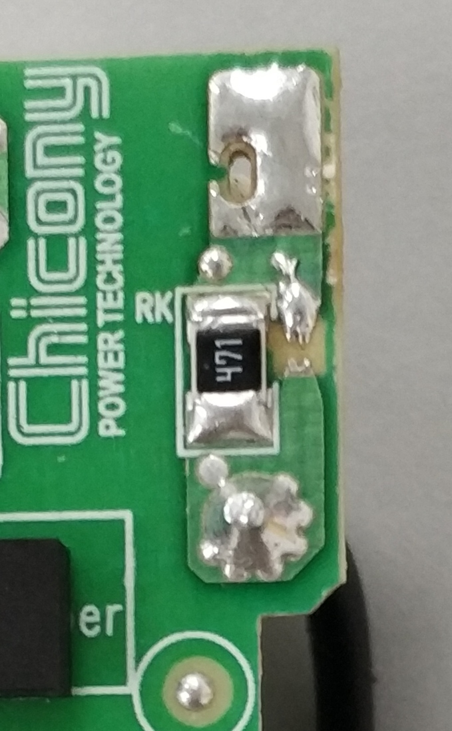
Before | After
- RD study縮短PCB板上RK的放電pin距離,由0.5mm縮短至0.4mm.預計在2020年7月中旬導入new PCB.
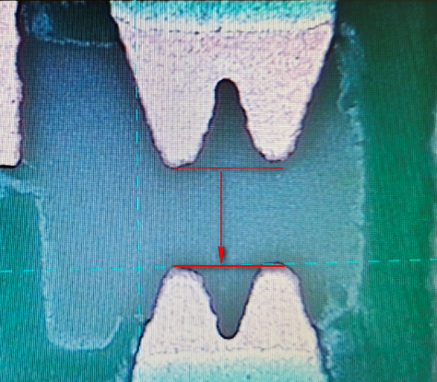
Owner:RD Due date:2020.07.15
D6.)改善措施實施日期:Implement Permanent Corrective Actions:
(Note: Be provide the phase-in date or lot# of corrective actions implementation in process)
2020.07.15
D7.)預防再發生措施:Prevent Recurrence:
(Note: Modified the management, operating systems, practices, and procedures to prevent recurrence for the problems as well as lessons learned cases.)
QIT members and IPQC will continue trace this issue day by day.
D8.)確認並感謝問題解決成員:Check and Congratulate the Team:
(Note: Recognize the collective efforts of the team.)
Thanks to all QIT members.

Signature Team Leader: | Henry_Zhang
 | Name – Title
Signature by Approver: | Roy_Tsai
 | Name-Title

